EER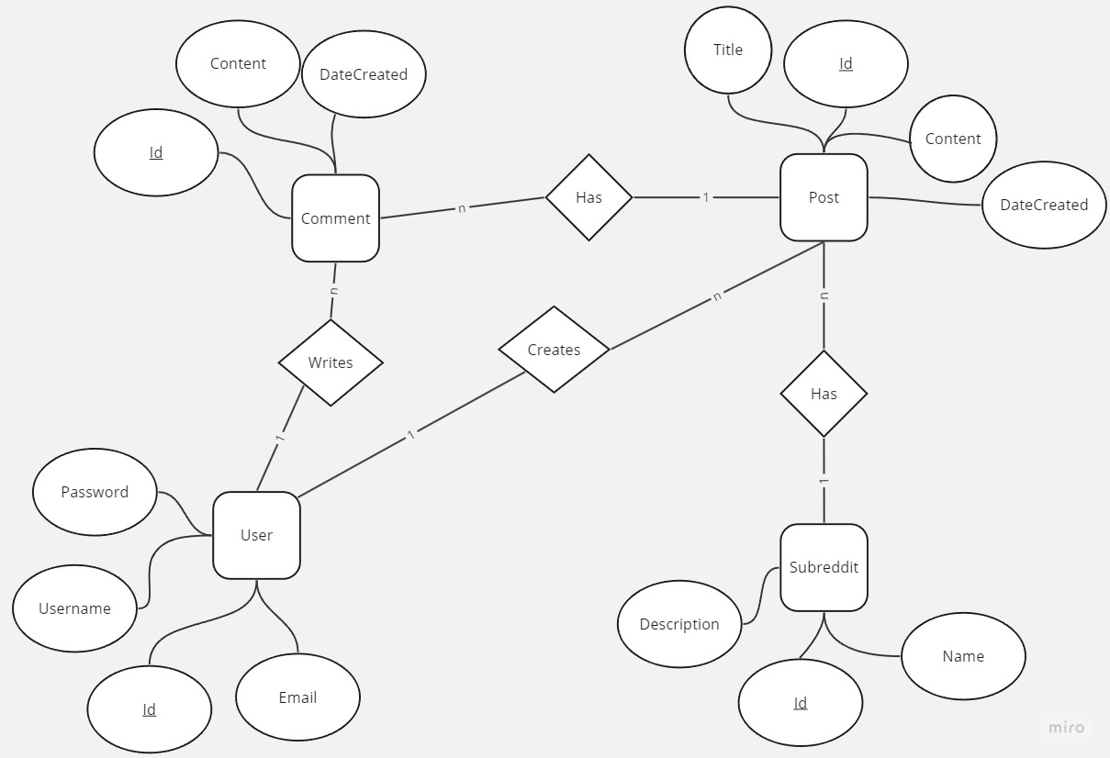

ERD

